**LAB # 06**

**SUPERVISED LEARNING (LINEAR REGRESSION)**

**OBJECTIVE**

Implementing supervised learning, linear regression algorithm for training, testing and classification.

**LAB TASK:-**

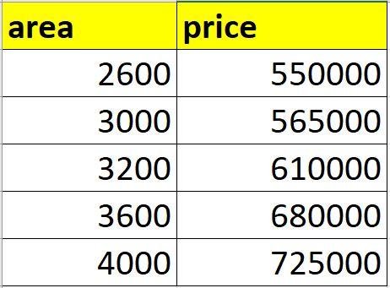

1.implement linear regression algorithm on above dataset predict price of home with areas in the dataset by using (homeprices.csv).

* **CODE:**

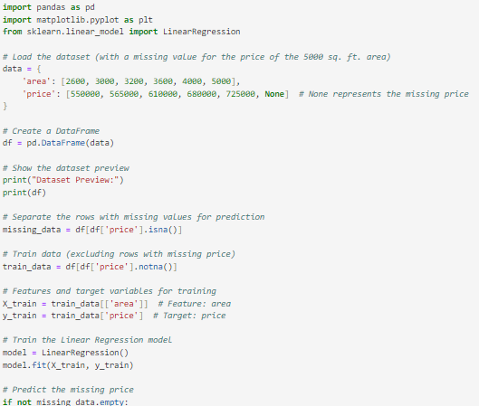

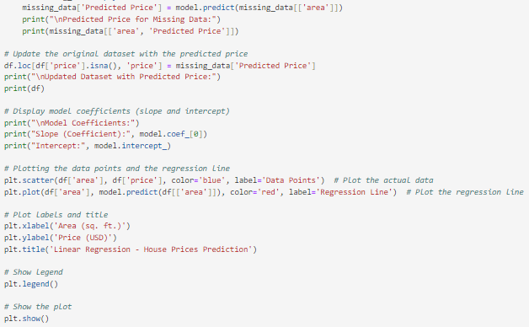

* **OUTPUT:**

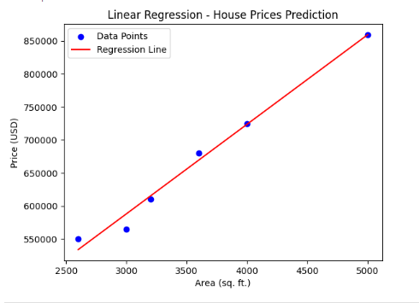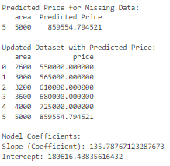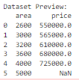

2.implement Implement linear regression using table 1 in such a way that the

**Predict price of a home with area = 5000 sqr ft**

**Predict price of a home with area = 8000 sqr ft**

**Predict price of a home with area = 9000 sqr ft**

* **CODE:**

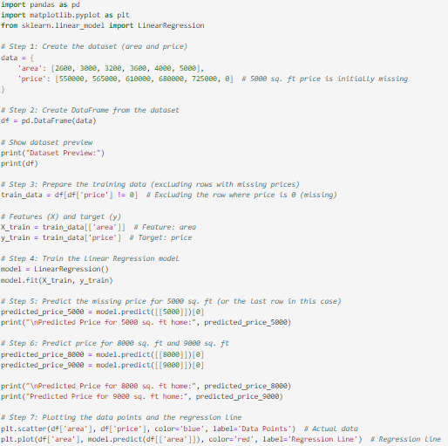

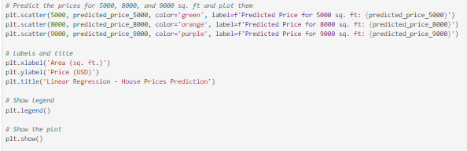

* **OUTPUT:**

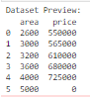

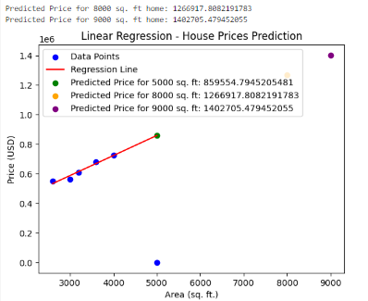

**HOME ASSIGNMENT:**

**Objective:** To implement a linear regression model that predicts home prices based on area (in square feet) using a dataset and visualizes the relationship.

| **Area (sqft)** | **Price ($)** |
| --- | --- |

|  |  |
| --- | --- |
| 1500 | 400,000 |

|  |  |  |
| --- | --- | --- |
| 1800 |  | 450,000 |

|  |  |
| --- | --- |
| 2000 | 475,000 |

|  |  |
| --- | --- |
| 2200 | 510,000 |

|  |  |
| --- | --- |
| 2500 | 550,000 |

|  |  |
| --- | --- |
| 2800 | 600,000 |

|  |  |
| --- | --- |
| 3000 | 625,000 |

|  |  |
| --- | --- |
| 3500 | 650,000 |

|  |  |
| --- | --- |
| 4000 | 700,000 |

|  |  |
| --- | --- |
| 4500 | 750,000 |

* **Code:**

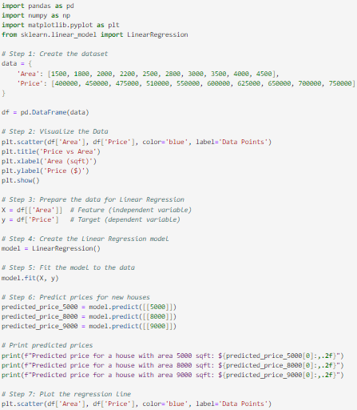

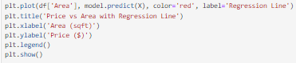

* 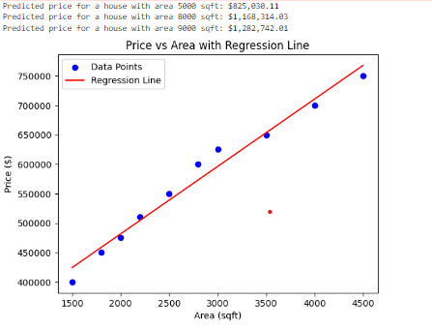**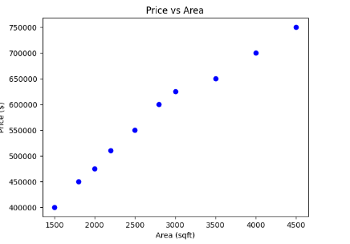Output:**

**Files Uploads On GitHub:**